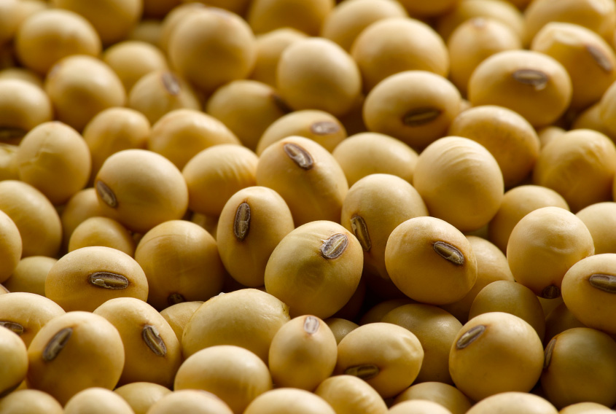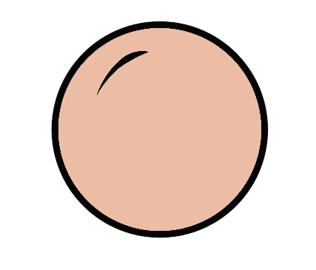

**Seed**

Seeds are planted in the spring. Farmers pull large planters behind tractors to do this.

**A**

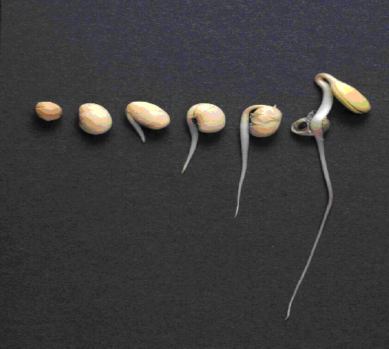

**Germination**

This is when the seed starts to grow. Seeds only need water and warmth to germinate. That is why seeds are planted when it gets warm!

**B**

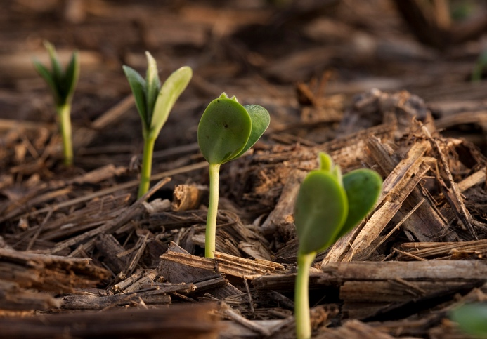

**Seedling**

A small plant is called a seedling. At this time, the plant will start needing nutrients and sunlight. Soybeans work with a type of bacteria that helps them get nutrients!

**C**

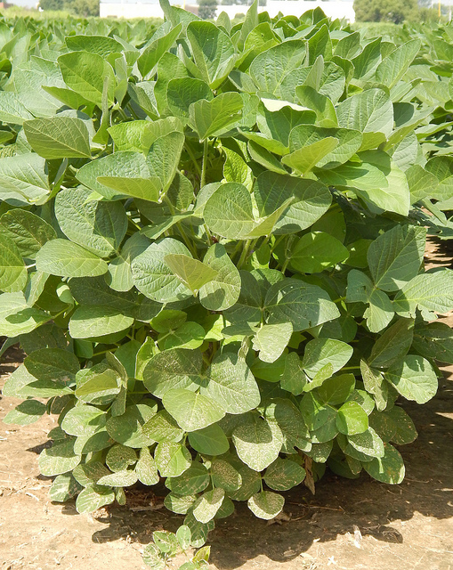

**Growing Plant**

Soybean plants grow to be about 3 feet tall. When they get too tall, farmers use special equipment to drive through the field. They check their fields for diseases, pests, and weeds that can hurt their plants.

**D**

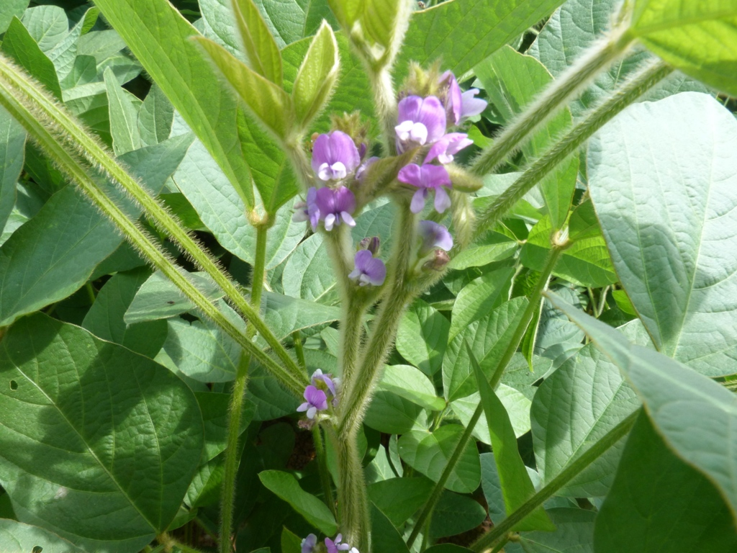

**Flowering**

Flowering is the first step in the plant’s reproduction. During this time, it will need more nutrients. Farmers may fertilize during this time.

**E**

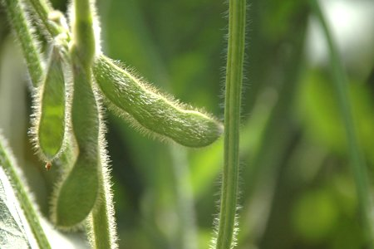

**Green Pod**

The green pods get larger as the seeds inside them grow. By the end of the summer, the plant is fully grown. The farmer will wait to harvest until the seeds are dry and hard.

**F**

[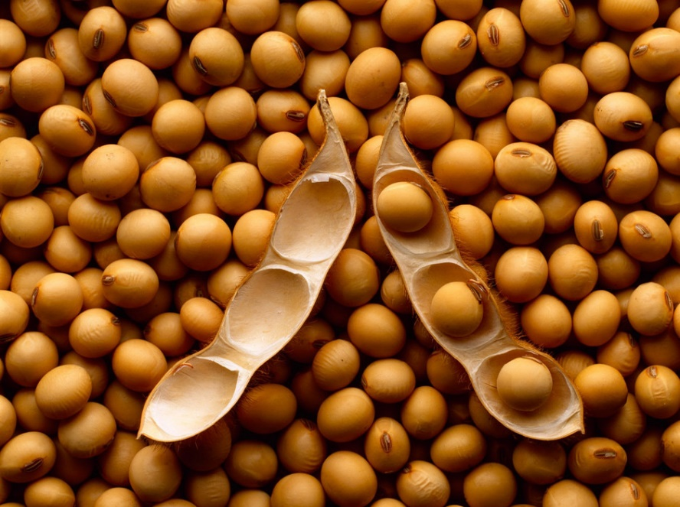](http://www.google.com/url?sa=i&rct=j&q=&esrc=s&source=images&cd=&cad=rja&uact=8&ved=0ahUKEwiDs8mHgp3RAhUGQiYKHfRHA2AQjRwIBw&url=http://www.arvglobaltrading.com/product/mature-soybean/&bvm=bv.142059868,d.eWE&psig=AFQjCNGIFSaXSm20G3eI6LfRSa60-_y3nQ&ust=1483225048555680)[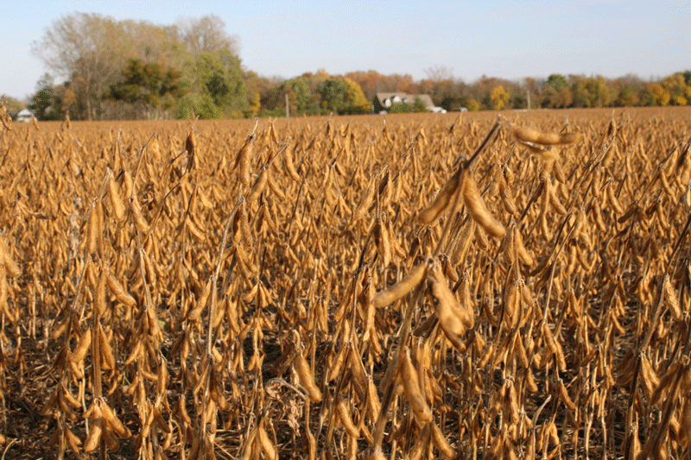](http://www.google.com/url?sa=i&rct=j&q=&esrc=s&source=images&cd=&cad=rja&uact=8&ved=0ahUKEwiIztr5gp3RAhWCPiYKHcSOA_AQjRwIBw&url=http://www.galinthemiddle.com/2011_10_01_archive.html&bvm=bv.142059868,d.eWE&psig=AFQjCNEC9jhefu18qyw666KCmzgBdkmZig&ust=1483225239401303)

**Mature Pod**

The plant has now lost its leaves, and the seeds are dry. It is now time for the farmer to harvest the soybeans using a combine!

**G**